UNITED STATES
SECURITIES AND EXCHANGE COMMISSION
WASHINGTON, D.C. 20549

FORM 6-K

REPORT OF FOREIGN PRIVATE ISSUER
PURSUANT TO RULE 13a-16 OR 15d-16 UNDER
THE SECURITIES EXCHANGE ACT OF 1934
For the month of September 2026
Commission File Number: 000-51469

BAIDU, INC.

Baidu Campus
No. 10 Shangdi 10th Street
Haidian District, Beijing 100085
The People’s Republic of China
(Address of principal executive offices)

Indicate by check mark whether the registrant files or will file annual reports under cover of Form 20-F or Form 40-F.
Form 20-F ☒ Form 40-F ☐

EXHIBIT INDEX

Exhibit No. |  | Description
99.1 |  | Press Release—Baidu Announces Inclusion of Its Class A Ordinary Shares in the Shenzhen-Hong Kong Stock Connect and Shanghai-Hong Kong Stock Connect Programs
99.2 |  | Voluntary Announcement—Baidu Announces Inclusion of Its Class A Ordinary Shares in the Shenzhen-Hong Kong Stock Connect
99.3 |  | Next Day Disclosure Return, dated September 8, 2026

SIGNATURES
Pursuant to the requirements of the Securities Exchange Act of 1934, the registrant has duly caused this report to be signed on its behalf by the undersigned, thereunto duly authorized.

BAIDU, INC.
By |  | : |  | /s/ Haijian He
Name |  | : |  | Haijian He
Title |  | : |  | Chief Financial Officer
Date: September 8, 2026
Exhibit 99.1
Baidu Announces Inclusion of Its Class A Ordinary Shares in the Shenzhen-Hong Kong Stock Connect and Shanghai-Hong Kong Stock Connect Programs
BEIJING, China, September 6, 2026 – Baidu, Inc. (“Baidu” or the “Company”) (Nasdaq: BIDU; HKEX: 9888 (HKD Counter) and 89888 (RMB Counter)), a leading AI company with strong Internet foundation, today announced that the Company’s Class A ordinary shares traded on The Stock Exchange of Hong Kong Limited (the “Hong Kong Stock Exchange”) have been included in the Shenzhen-Hong Kong Stock Connect program, effective today, September 7, 2026 (Beijing time). The previously announced inclusion of the Company’s Class A ordinary shares in the Shanghai-Hong Kong Stock Connect program also became effective today. Eligible investors in the Chinese Mainland now have direct access to the trading of Baidu’s Class A ordinary shares through both programs.
The inclusion of Baidu’s Class A ordinary shares in the Shenzhen-Hong Kong Stock Connect program is pursuant to the Announcement on Adjustment of the List of the Eligible Stocks in Hong Kong Stock Connect under the Shenzhen-Hong Kong Stock Connect issued by the Shenzhen Stock Exchange on September 7, 2026.
Taken together, the inclusion in the Shanghai-Hong Kong Stock Connect and the Shenzhen-Hong Kong Stock Connect marks an important step toward expanding the Company’s reach among Chinese Mainland investors and is expected to further diversify its investor base and enhance the liquidity of its shares.
Baidu appreciates the continued support of its shareholders and investors and remains committed to driving sustainable growth and creating long-term value for shareholders.
About the Shenzhen-Hong Kong Stock Connect
The Shenzhen-Hong Kong Stock Connect is a mutual stock market access mechanism between the Chinese Mainland and Hong Kong under which the Shenzhen Stock Exchange and the Hong Kong Stock Exchange have established technical connectivity to enable investors in the Chinese Mainland and Hong Kong to trade eligible shares listed on the other’s market through their local securities companies or brokers.
About the Shanghai-Hong Kong Stock Connect
The Shanghai-Hong Kong Stock Connect established a two-way trading link between the Shanghai Stock Exchange and the Hong Kong Stock Exchange. The stock connect allows qualified Chinese Mainland investors to access eligible Hong Kong shares (Southbound) as well as Hong Kong and overseas investors to trade eligible A-shares (Northbound), subject to a certain amount of daily quota.
About Baidu
Founded in 2000, Baidu’s mission is to make the complicated world simpler through technology. Baidu is a leading AI company with strong Internet foundation, trading on Nasdaq under “BIDU” and HKEX under “9888”. One Baidu ADS represents eight Class A ordinary shares.

1

Safe Harbor Statement
This announcement contains forward-looking statements. These statements are made under the “safe harbor” provisions of the U.S. Private Securities Litigation Reform Act of 1995. These forward-looking statements can be identified by terminology such as “will,” “expects,” “anticipates,” “future,” “intends,” “plans,” “believes,” “estimates,” “confident” and similar statements. Among other things, Baidu’s and other parties’ strategic and operational plans, contain forward-looking statements. Baidu may also make written or oral forward-looking statements in its periodic reports to the U.S. Securities and Exchange Commission, in announcements made on the website of the Hong Kong Stock Exchange, in its annual report to shareholders, in press releases and other written materials and in oral statements made by its officers, directors or employees to third parties. Statements that are not historical facts, including but not limited to statements about Baidu’s beliefs and expectations, are forward-looking statements. Forward-looking statements involve inherent risks and uncertainties. A number of factors could cause actual results to differ materially from those contained in any forward-looking statement, including but not limited to the following: Baidu’s growth strategies; its future business development, including development of new products and services; its ability to attract and retain users and customers; competition in the Chinese Internet search and newsfeed market; competition for online marketing customers; changes in the Company’s revenues and certain cost or expense items as a percentage of its revenues; the outcome of ongoing, or any future, litigation or arbitration, including those relating to intellectual property rights; the expected growth of the Chinese-language Internet search and newsfeed market and the number of Internet and broadband users in China; Chinese governmental policies relating to the Internet and Internet search providers, and general economic conditions in China and elsewhere. Further information regarding these and other risks is included in the Company’s annual report on Form 20-F and other documents filed with the Securities and Exchange Commission, and announcements on the website of the Hong Kong Stock Exchange. Baidu does not undertake any obligation to update any forward-looking statement, except as required under applicable law. All information provided in this press release and in the attachments is as of the date of the press release, and Baidu undertakes no duty to update such information, except as required under applicable law.
SOURCE Baidu, Inc.
Investor Relations, Baidu, Inc., Tel: +86-10-5992-8888, Email: ir@baidu.com

2
Exhibit 99.2
Hong Kong Exchanges and Clearing Limited and The Stock Exchange of Hong Kong Limited take no responsibility for the contents of this announcement, make no representation as to its accuracy or completeness and expressly disclaim any liability whatsoever for any loss howsoever arising from or in reliance upon the whole or any part of the contents of this announcement.
Under our weighted voting rights structure, our share capital comprises Class A ordinary shares and Class B ordinary shares. Each Class A ordinary share entitles the holder to exercise one vote, and each Class B ordinary share entitles the holder to exercise 10 votes, respectively, on all matters subject to the vote at general meetings of the Company. Shareholders and prospective investors should be aware of the potential risks of investing in a company with a weighted voting rights structure. Our American depositary shares, each representing eight of our Class A ordinary shares, are listed on Nasdaq in the United States under the symbol BIDU.


Baidu, Inc.
百度集團股份有限公司
(A company controlled through weighted voting rights and incorporated in the Cayman Islands with limited liability)
(Stock Codes: 9888 (HKD counter) and 89888 (RMB counter))
VOLUNTARY ANNOUNCEMENT
BAIDU ANNOUNCES INCLUSION OF ITS CLASS A
ORDINARY SHARES IN THE SHENZHEN-HONG KONG STOCK CONNECT
This announcement is made by Baidu, Inc. (the “Company”) on a voluntary basis to provide its shareholders and potential investors with information in relation to the latest development of the Company.
Reference is made to the announcement of the Company dated September 4, 2026 in relation to the inclusion of its Class A ordinary shares as eligible stocks under the Shanghai-Hong Kong Stock Connect.
The Company is pleased to announce that the Class A ordinary shares of the Company have been included as eligible stocks under the Shenzhen-Hong Kong Stock Connect with effect from September 7, 2026, pursuant to 《關於深港通下的港股通標的證券名單調整的公告》 (Announcement on Adjustment of the List of the Eligible Stocks in Hong Kong Stock Connect under the Shenzhen-Hong Kong Stock Connect*) issued by the Shenzhen Stock Exchange on September 7, 2026.
The Company believes that its inclusion in the Shanghai-Hong Kong Stock Connect and the Shenzhen-Hong Kong Stock Connect marks an important step toward expanding the Company’s reach among Chinese Mainland investors and is expected to further diversify its investor base and enhance the liquidity of its shares.

1

The Company would like to thank the continued support of its shareholders and investors and remains committed to executing its long-term strategy, driving sustainable growth and creating long-term value for its shareholders.
Shareholders of the Company and potential investors are advised to exercise caution when dealing in the shares or other securities of the Company.

By order of the Board
Baidu, Inc.
Mr. Robin Yanhong Li
Chairman of the Board
and Chief Executive Officer
Hong Kong, September 7, 2026
As at the date of this announcement, the board of directors of the Company comprises Mr. Robin Yanhong Li as director, and Mr. Yuanqing Yang, Mr. Jixun Foo, Ms. Sandy Ran Xu and Ms. Xiaodan Liu as independent directors.

* | For identification purposes only

2
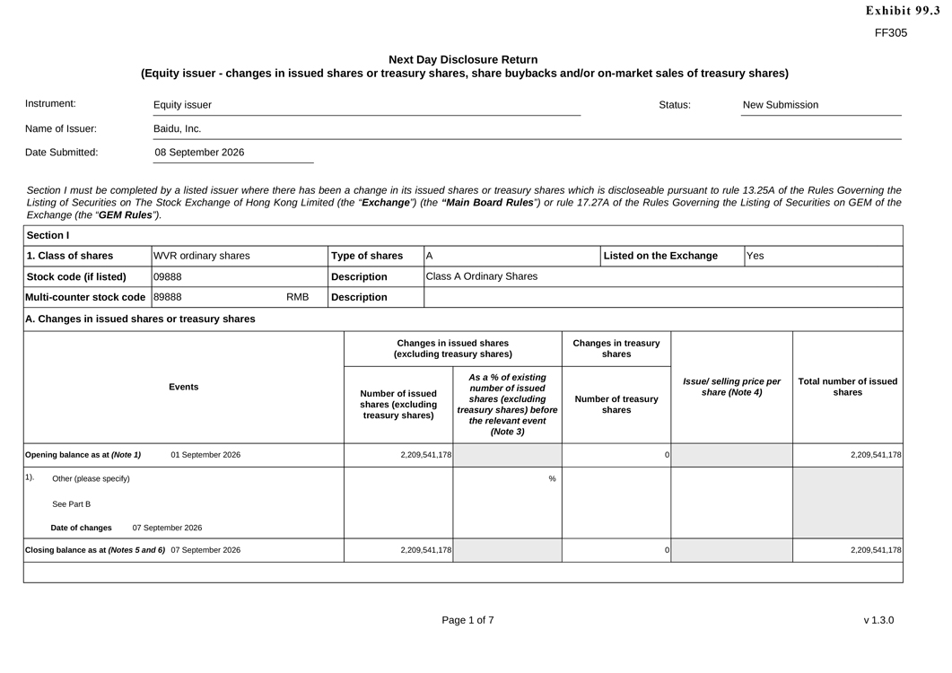
FF305 Next Day Disclosure Return (Equity issuer—changes in issued shares or treasury shares, share buybacks and/or on-market sales of treasury shares) Instrument: Equity issuer Status: New Submission Name of Issuer: Baidu, Inc. Date Submitted: 08 September 2026 Section I must be completed by a listed issuer where there has been a change in its issued shares or treasury shares which is discloseable pursuant to rule 13.25A of the Rules Governing the Listing of Securities on The Stock Exchange of Hong Kong Limited (the “Exchange”) (the “Main Board Rules”) or rule 17.27A of the Rules Governing the Listing of Securities on GEM of the Exchange (the “GEM Rules”). Section I 1. Class of shares WVR ordinary shares Type of shares A Listed on the Exchange Yes Stock code (if listed) 09888 Description Class A Ordinary Shares Multi-counter stock code 89888 RMB Description A. Changes in issued shares or treasury shares Changes in issued shares Changes in treasury (excluding treasury shares) shares Events As a % of existing Issue/ selling price per Total number of issued number of issued share (Note 4) shares Number of issued shares (excluding Number of treasury shares (excluding treasury shares) before shares treasury shares) the relevant event (Note 3) Opening balance as at (Note 1) 01 September 2026 2,209,541,178 0 2,209,541,178 1). Other (please specify) % See Part B Date of changes 07 September 2026 Closing balance as at (Notes 5 and 6) 07 September 2026 2,209,541,178 0 2,209,541,178 Page 1 of 7 v 1.3.0

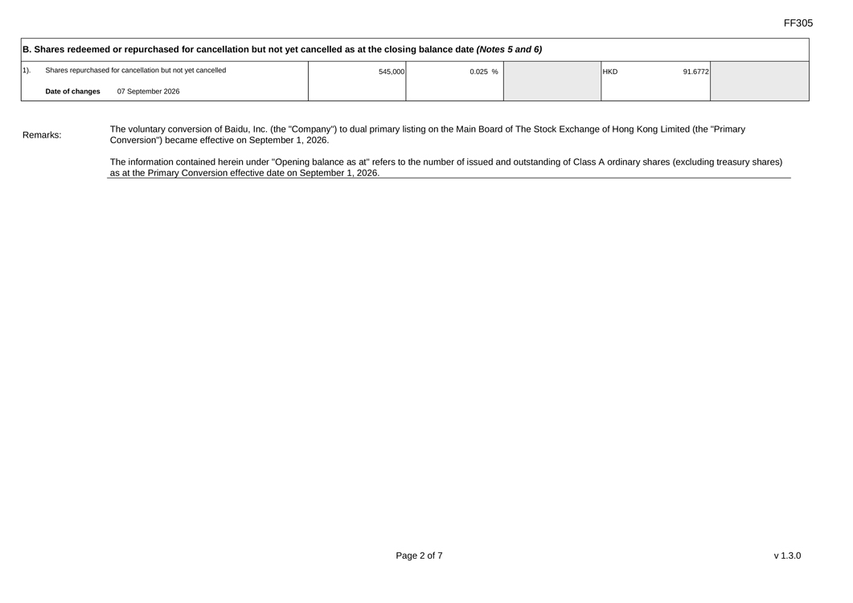
FF305 B. Shares redeemed or repurchased for cancellation but not yet cancelled as at the closing balance date (Notes 5 and 6) 1). Shares repurchased for cancellation but not yet cancelled 545,000 0.025 % HKD 91.6772 Date of changes 07 September 2026 The voluntary conversion of Baidu, Inc. (the “Company”) to dual primary listing on the Main Board of The Stock Exchange of Hong Kong Limited (the “Primary Remarks: Conversion”) became effective on September 1, 2026. The information contained herein under “Opening balance as at” refers to the number of issued and outstanding of Class A ordinary shares (excluding treasury shares) as at the Primary Conversion effective date on September 1, 2026. Page 2 of 7 v 1.3.0

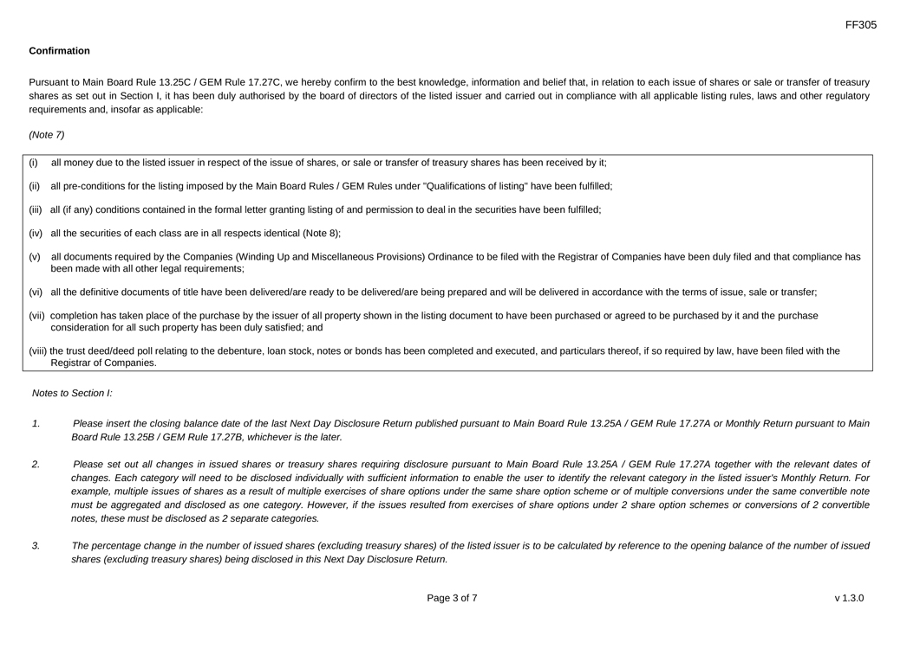
FF305 Confirmation Pursuant to Main Board Rule 13.25C / GEM Rule 17.27C, we hereby confirm to the best knowledge, information and belief that, in relation to each issue of shares or sale or transfer of treasury shares as set out in Section I, it has been duly authorised by the board of directors of the listed issuer and carried out in compliance with all applicable listing rules, laws and other regulatory requirements and, insofar as applicable: (Note 7) (i) all money due to the listed issuer in respect of the issue of shares, or sale or transfer of treasury shares has been received by it; (ii) all pre-conditions for the listing imposed by the Main Board Rules / GEM Rules under “Qualifications of listing” have been fulfilled; (iii) all (if any) conditions contained in the formal letter granting listing of and permission to deal in the securities have been fulfilled; (iv) all the securities of each class are in all respects identical (Note 8); (v) all documents required by the Companies (Winding Up and Miscellaneous Provisions) Ordinance to be filed with the Registrar of Companies have been duly filed and that compliance has been made with all other legal requirements; (vi) all the definitive documents of title have been delivered/are ready to be delivered/are being prepared and will be delivered in accordance with the terms of issue, sale or transfer; (vii) completion has taken place of the purchase by the issuer of all property shown in the listing document to have been purchased or agreed to be purchased by it and the purchase consideration for all such property has been duly satisfied; and (viii) the trust deed/deed poll relating to the debenture, loan stock, notes or bonds has been completed and executed, and particulars thereof, if so required by law, have been filed with the Registrar of Companies. Notes to Section I: 1. Please insert the closing balance date of the last Next Day Disclosure Return published pursuant to Main Board Rule 13.25A / GEM Rule 17.27A or Monthly Return pursuant to Main Board Rule 13.25B / GEM Rule 17.27B, whichever is the later. 2. Please set out all changes in issued shares or treasury shares requiring disclosure pursuant to Main Board Rule 13.25A / GEM Rule 17.27A together with the relevant dates of changes. Each category will need to be disclosed individually with sufficient information to enable the user to identify the relevant category in the listed issuer’s Monthly Return. For example, multiple issues of shares as a result of multiple exercises of share options under the same share option scheme or of multiple conversions under the same convertible note must be aggregated and disclosed as one category. However, if the issues resulted from exercises of share options under 2 share option schemes or conversions of 2 convertible notes, these must be disclosed as 2 separate categories. 3. The percentage change in the number of issued shares (excluding treasury shares) of the listed issuer is to be calculated by reference to the opening balance of the number of issued shares (excluding treasury shares) being disclosed in this Next Day Disclosure Return. Page 3 of 7 v 1.3.0

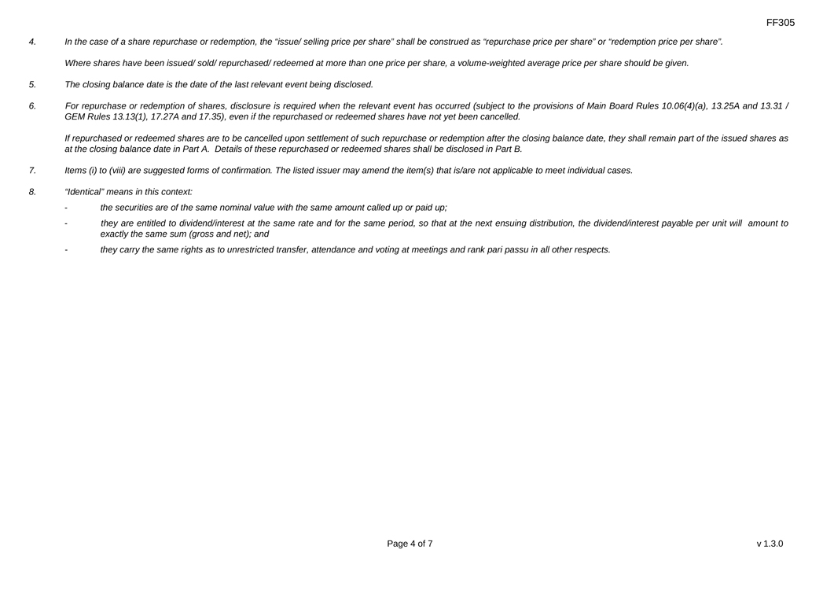
FF305 4. In the case of a share repurchase or redemption, the “issue/ selling price per share” shall be construed as “repurchase price per share” or “redemption price per share”. Where shares have been issued/ sold/ repurchased/ redeemed at more than one price per share, a volume-weighted average price per share should be given. 5. The closing balance date is the date of the last relevant event being disclosed. 6. For repurchase or redemption of shares, disclosure is required when the relevant event has occurred (subject to the provisions of Main Board Rules 10.06(4)(a), 13.25A and 13.31 / GEM Rules 13.13(1), 17.27A and 17.35), even if the repurchased or redeemed shares have not yet been cancelled. If repurchased or redeemed shares are to be cancelled upon settlement of such repurchase or redemption after the closing balance date, they shall remain part of the issued shares as at the closing balance date in Part A. Details of these repurchased or redeemed shares shall be disclosed in Part B. 7. Items (i) to (viii) are suggested forms of confirmation. The listed issuer may amend the item(s) that is/are not applicable to meet individual cases. 8. “Identical” means in this context: - the securities are of the same nominal value with the same amount called up or paid up; - they are entitled to dividend/interest at the same rate and for the same period, so that at the next ensuing distribution, the dividend/interest payable per unit will amount to exactly the same sum (gross and net); and - they carry the same rights as to unrestricted transfer, attendance and voting at meetings and rank pari passu in all other respects. Page 4 of 7 v 1.3.0

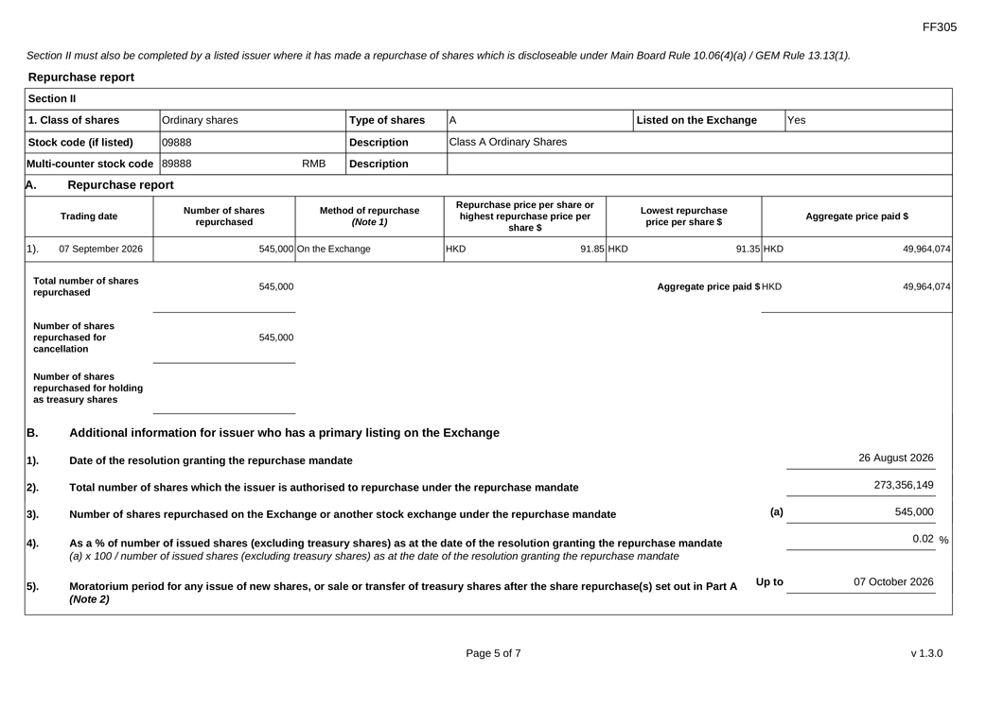
FF305 Section II must also be completed by a listed issuer where it has made a repurchase of shares which is discloseable under Main Board Rule 10.06(4)(a) / GEM Rule 13.13(1). Repurchase report Section II 1. Class of shares Ordinary shares Type of shares A Listed on the Exchange Yes Stock code (if listed) 09888 Description Class A Ordinary Shares Multi-counter stock code 89888 RMB Description A. Repurchase report Repurchase price per share or Number of shares Method of repurchase Lowest repurchase Trading date highest repurchase price per Aggregate price paid $ repurchased (Note 1) price per share $ share $ 1). 07 September 2026 545,000 On the Exchange HKD 91.85 HKD 91.35 HKD 49,964,074 Total number of shares 545,000 Aggregate price paid $ HKD 49,964,074 repurchased Number of shares repurchased for 545,000 cancellation Number of shares repurchased for holding as treasury shares B. Additional information for issuer who has a primary listing on the Exchange 1). Date of the resolution granting the repurchase mandate 26 August 2026 2). Total number of shares which the issuer is authorised to repurchase under the repurchase mandate 273,356,149 3). Number of shares repurchased on the Exchange or another stock exchange under the repurchase mandate (a) 545,000 4). As a % of number of issued shares (excluding treasury shares) as at the date of the resolution granting the repurchase mandate 0.02 % (a) x 100 / number of issued shares (excluding treasury shares) as at the date of the resolution granting the repurchase mandate 5). Moratorium period for any issue of new shares, or sale or transfer of treasury shares after the share repurchase(s) set out in Part A Up to 07 October 2026 (Note 2) Page 5 of 7 v 1.3.0

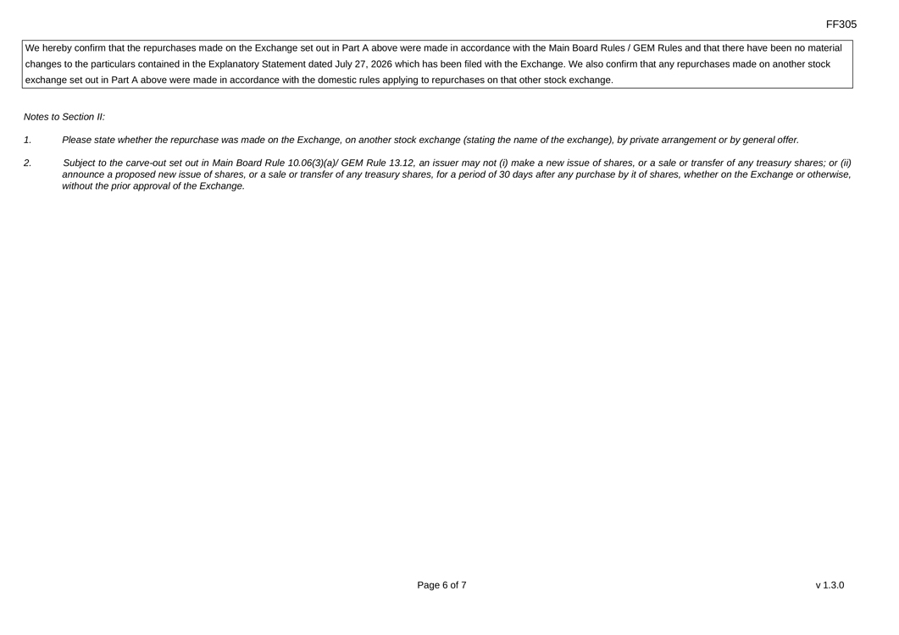
FF305 We hereby confirm that the repurchases made on the Exchange set out in Part A above were made in accordance with the Main Board Rules / GEM Rules and that there have been no material changes to the particulars contained in the Explanatory Statement dated July 27, 2026 which has been filed with the Exchange. We also confirm that any repurchases made on another stock exchange set out in Part A above were made in accordance with the domestic rules applying to repurchases on that other stock exchange. Notes to Section II: 1. Please state whether the repurchase was made on the Exchange, on another stock exchange (stating the name of the exchange), by private arrangement or by general offer. 2. Subject to the carve-out set out in Main Board Rule 10.06(3)(a)/ GEM Rule 13.12, an issuer may not (i) make a new issue of shares, or a sale or transfer of any treasury shares; or (ii) announce a proposed new issue of shares, or a sale or transfer of any treasury shares, for a period of 30 days after any purchase by it of shares, whether on the Exchange or otherwise, without the prior approval of the Exchange. Page 6 of 7 v 1.3.0

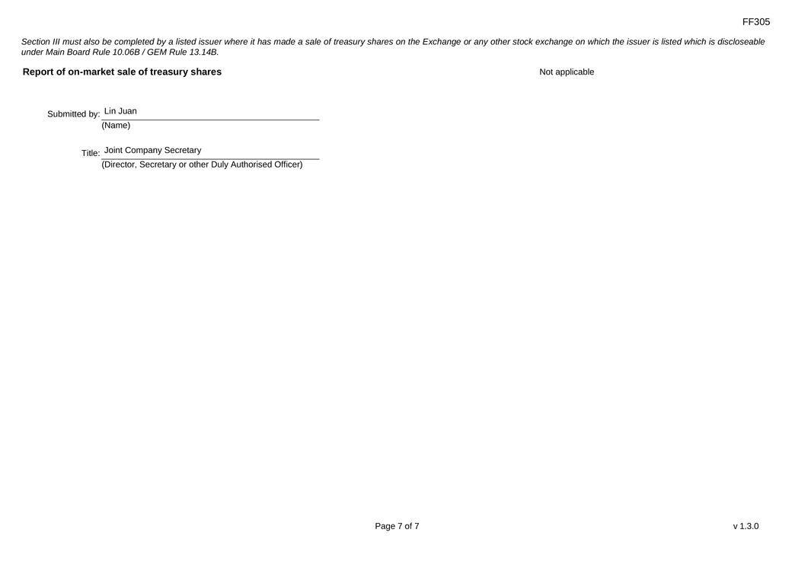
FF305 Section III must also be completed by a listed issuer where it has made a sale of treasury shares on the Exchange or any other stock exchange on which the issuer is listed which is discloseable under Main Board Rule 10.06B / GEM Rule 13.14B. Report of on-market sale of treasury shares Not applicable Submitted by: Lin Juan (Name) Title: Joint Company Secretary (Director, Secretary or other Duly Authorised Officer) Page 7 of 7 v 1.3.0

