UNITED STATES
SECURITIES AND EXCHANGE COMMISSION
WASHINGTON, D.C. 20549

FORM 6-K

REPORT OF FOREIGN PRIVATE ISSUER
PURSUANT TO RULE 13a-16 OR 15d-16
UNDER THE SECURITIES EXCHANGE ACT OF 1934
For the month of October 2026
Commission File Number: 000-51469

BAIDU, INC.

Baidu Campus
No. 10 Shangdi 10th Street
Haidian District, Beijing 100085
The People’s Republic of China
(Address of principal executive offices)

Indicate by check mark whether the registrant files or will file annual reports under cover of Form 20-F or Form 40-F.
Form 20-F ☒ Form 40-F ☐

EXPLANATORY NOTE
We submitted with The Stock Exchange of Hong Kong Limited a monthly return form dated October 7, 2026 in relation to the movements in our authorized share capital and issued shares in September 2026, attached as Exhibit 99.1 to this current report on Form 6-K.

EXHIBIT INDEX

Exhibit No. |  | Description
99.1 |  | Monthly Return with The Stock Exchange of Hong Kong Limited – Monthly Return for Equity Issuer and Hong Kong Depositary Receipts listed under Chapter 19B of the Exchange Listing Rules on Movements in Securities

SIGNATURES
Pursuant to the requirements of the Securities Exchange Act of 1934, the registrant has duly caused this report to be signed on its behalf by the undersigned, thereunto duly authorized.

BAIDU, INC.
By: |  | /s/ Haijian He
Name: |  | Haijian He
Title: |  | Chief Financial Officer
Date: October 7, 2026
Exhibit 99.1

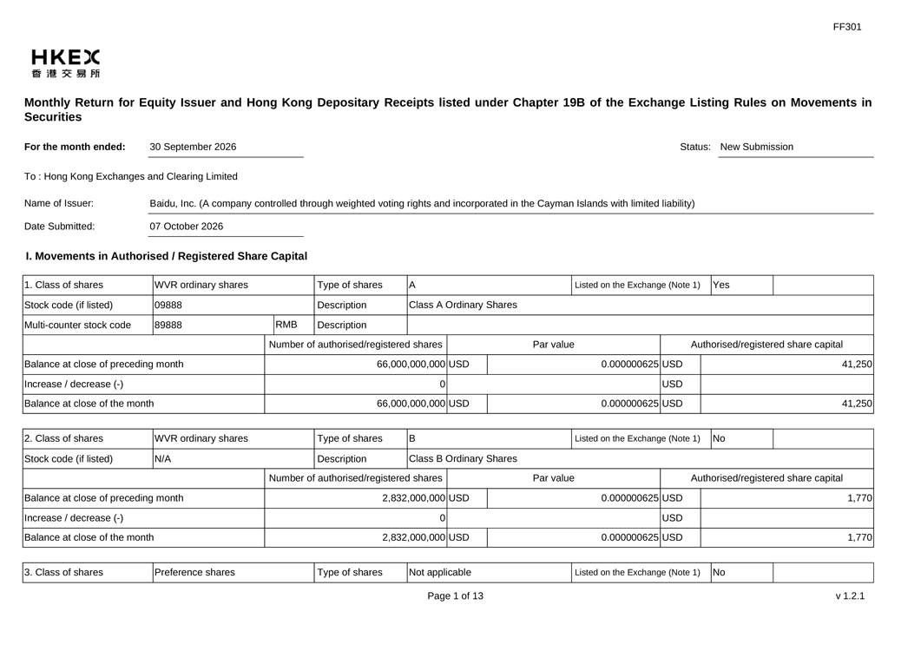
FF301 30 September 2026 Status: New Submission Name of Issuer: Date Submitted: HKEX Monthly Return for Equity Issuer and Hong Kong Depositary Receipts listed under Chapter 19B of the Exchange Listing Rules on Movements in Securities For the month ended: To : Hong Kong Exchanges and Clearing Limited Baidu, Inc. (A company controlled through weighted voting rights and incorporated in the Cayman Islands with limited liability) 07 October 2026 I. Movements in Authorised / Registered Share Capital 1. Class of shares Stock code (if listed) Multi-counter stock code WVR ordinary shares 09888 89888 Class A Ordinary Shares RME Par value O 66,000,000,000 USD 41,250 2. Class of shares Stock code (if listed) Balance at close of preceding month Increase / decrease (-) Balance at close of the month WVR ordinary shares N/A Type of shares Description Description Number of authorised/registered shares 66,000,000,000 USD A Listed on the Exchange (Note 1) Yes 0.000000625 USD USD 0.000000625 USD Authorised/registered share capital 41,250 B Class B Ordinary Shares No Par value Authorised/registered share capital Balance at close of preceding month Increase / decrease (-) Balance at close of the month Type of shares Description Number of authorised/registered shares 2,832,000,000 USD Listed on the Exchange (Note 1) 1,770 O 3. Class of shares Preference shares 2,832,000,000 USD Type of shares 0.000000625 USD USD 0.000000625 USD 1,770 Not applicable Page 1 of 13 Listed on the Exchange (Note 1) No v1.2.1

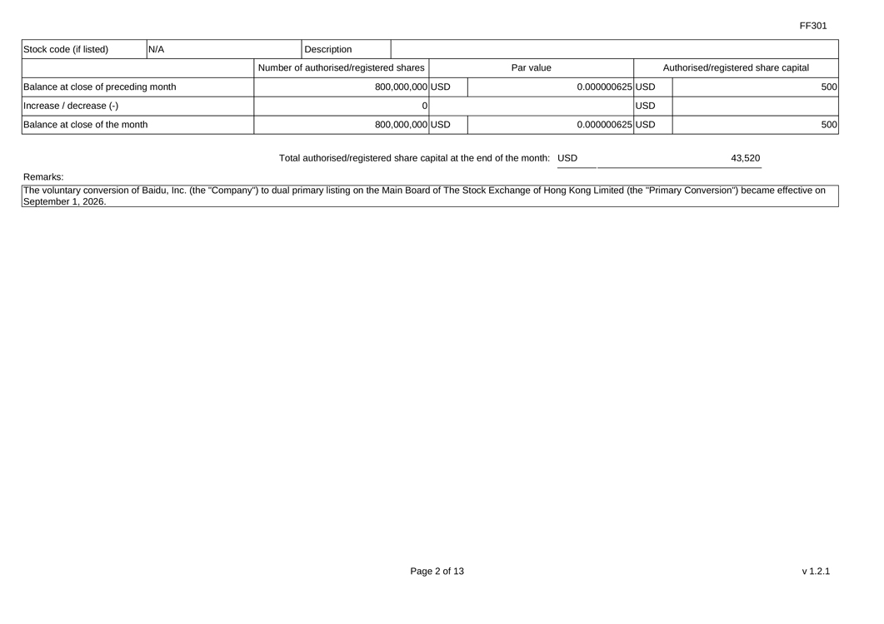
FF301 Stock code (if listed) N/A Par value Authorised/registered share capital Balance at close of preceding month Increase / decrease (-) Balance at close of the month Description Number of authorised/registered shares 800,000,000 USD O 800,000,000 USD Total authorised/registered share capital at the end of the month: USD The voluntary conversion of Baidu, Inc. (the “Company”) to dual primary listing on the Main Board of The Stock Exchange of Hong Kong Limited (the “Primary Conversion”) became effective on September 1, 2026. 0.000000625 USD USD 0.000000625 USD 500 500 43,520 Remarks: Page 2 of 13 v1.2.1

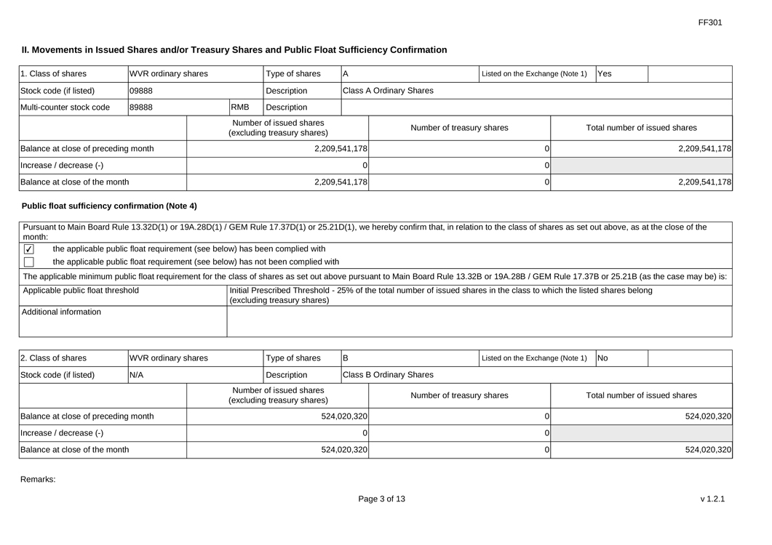
FF301 1. Class of shares Stock code (if listed) Multi-counter stock code Il. Movements in Issued Shares and/or Treasury Shares and Public Float Sufficiency Confirmation WVR ordinary shares 09888 89888 A Class A Ordinary Shares RMB Number of treasury shares Balance at close of preceding month Increase / decrease (-) Balance at close of the month Public float sufficiency confirmation (Note 4) Pursuant to Main Board Rule 13.32D(1) or 19A.28D(1) / GEM Rule 17.37D(1) or 25.21D(1), we hereby confirm that, in relation to the class of shares as set out above, as at the close of the month Type of shares Description Description Number of issued shares (excluding treasury shares) 2,209,541,178 Listed on the Exchange (Note 1) Yes Total number of issued shares 2,209,541,178 O O 2,209,541,178 0 2,209,541,178 Applicable public float threshold Additional information the applicable public float requirement (see below) has been complied with the applicable public float requirement (see below) has not been complied with The applicable minimum public float requirement for the class of shares as set out above pursuant to Main Board Rule 13.32B or 19A.28B / GEM Rule 17.37B or 25.21B (as the case may be) is: Initial Prescribed Threshold—25% of the total number of issued shares in the class to which the listed shares belong (excluding treasury shares) 2. Class of shares Stock code (if listed) WVR ordinary shares N/A Class B Ordinary Shares Number of treasury shares Balance at close of preceding month Increase / decrease (-) Balance at close of the month Type of shares Description Number of issued shares (excluding treasury shares) 524,020,320 Listed on the Exchange (Note 1) No Total number of issued shares 524,020,320 O 524,020,320 0 524,020,320 Remarks: Page 3 of 13 v1.2.1

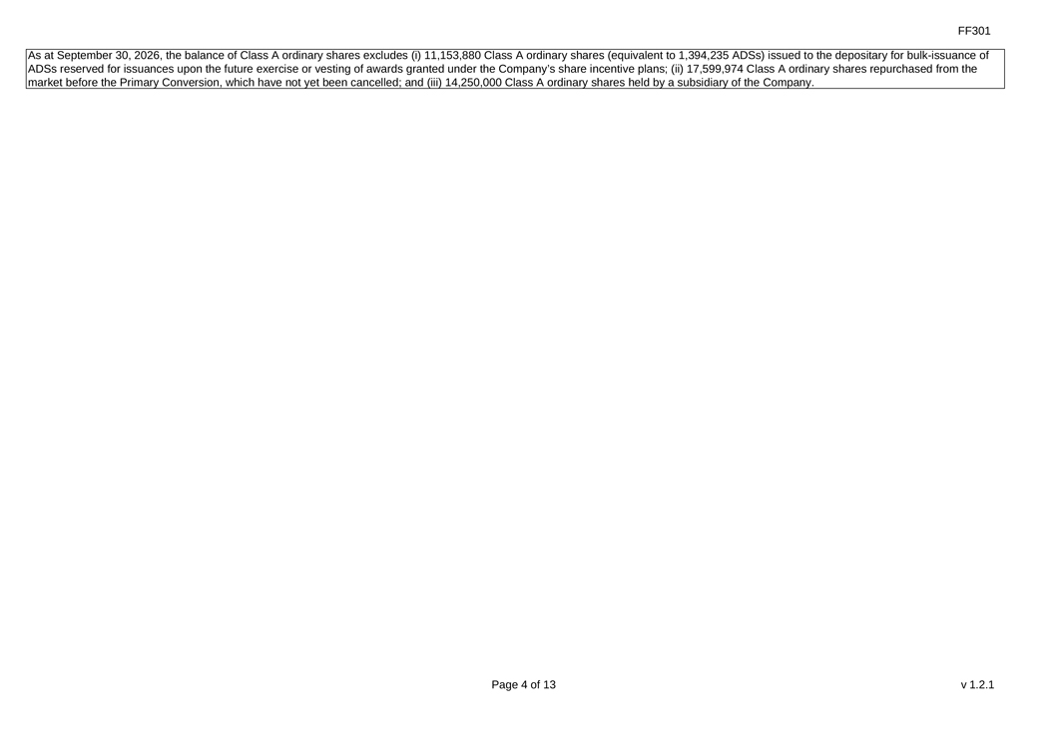
FF301 As at September 30, 2026, the balance of Class A ordinary shares excludes (0) 11,153,880 Class A ordinary shares (equivalent to 1,394,235 ADSs) issued to the depositary for bulk-issuance of ADSs reserved for issuances upon the future exercise or vesting of awards granted under the Company’s share incentive plans; (ii) 17,599,974 Class A ordinary shares repurchased from the market before the Primary Conversion, which have not yet been cancelled; and (iii) 14,250,000 Class A ordinary shares held by a subsidiary of the Company. Page 4 of 13 v1.2.1

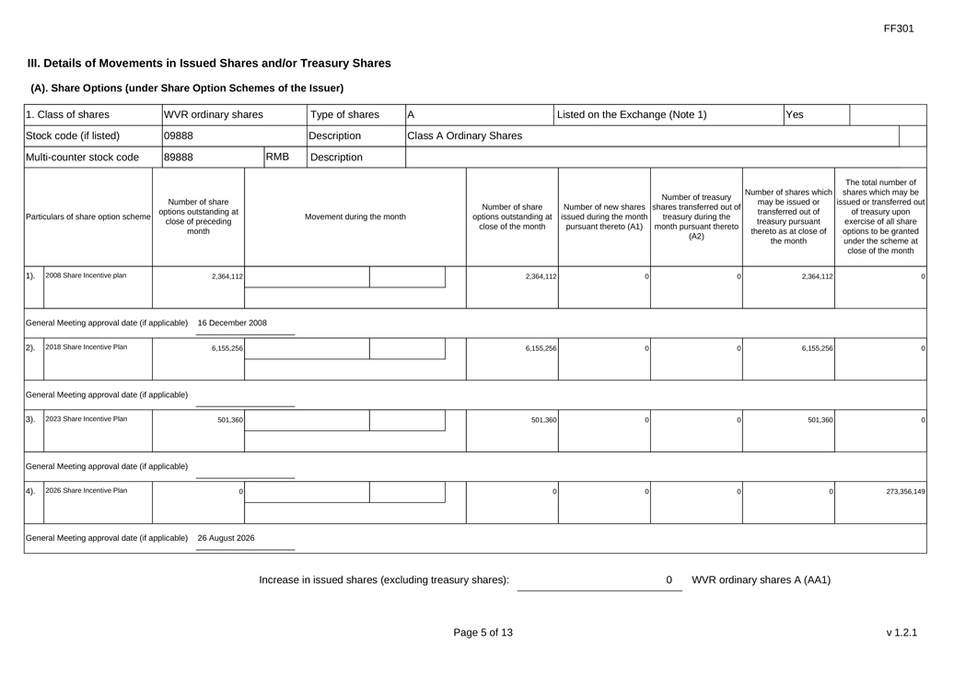
FF301 III. Details of Movements in Issued Shares and/or Treasury Shares (A). Share Options (under Share Option Schemes of the Issuer) 1. Class of shares Stock code (if listed) Multi-counter stock code WVR ordinary shares 09888 89888 A Class A Ordinary Shares Yes RMB Type of shares Description Description Listed on the Exchange (Note 1) Particulars of share option scheme Number of share options outstanding at close of preceding month Movement during the month Number of share options outstanding at close of the month Number of treasury Number of new shares |shares transferred out of issued during the month pursuant thereto (A1) treasury during the month pursuant thereto (A2) Number of shares which may be issued or transferred out of treasury pursuant thereto as at close of the month The total number of shares which may be issued or transferred out of treasury upon exercise of all share options to be granted under the scheme at close of the month 1). 2008 Share Incontive plan 2,364,112 2,364,112 2,364,112 General Meeting approval date (if applicable) 16 December 2008 2018 Share Incantive Plan 6,155,256 6,155,256 6,155,256 3) General Meeting approval date (if applicable) 2023 Share Incontive Plan 501,360 501,360 501,360 General Meeting approval date (if applicable) 4). 2026 Share Incentive Plan 273,356,149 General Meeting approval date (if applicable) 26 August 2026 Increase in issued shares (excluding treasury shares): 0 WVR ordinary shares A (AA1) Page 5 of 13 v1.2.1

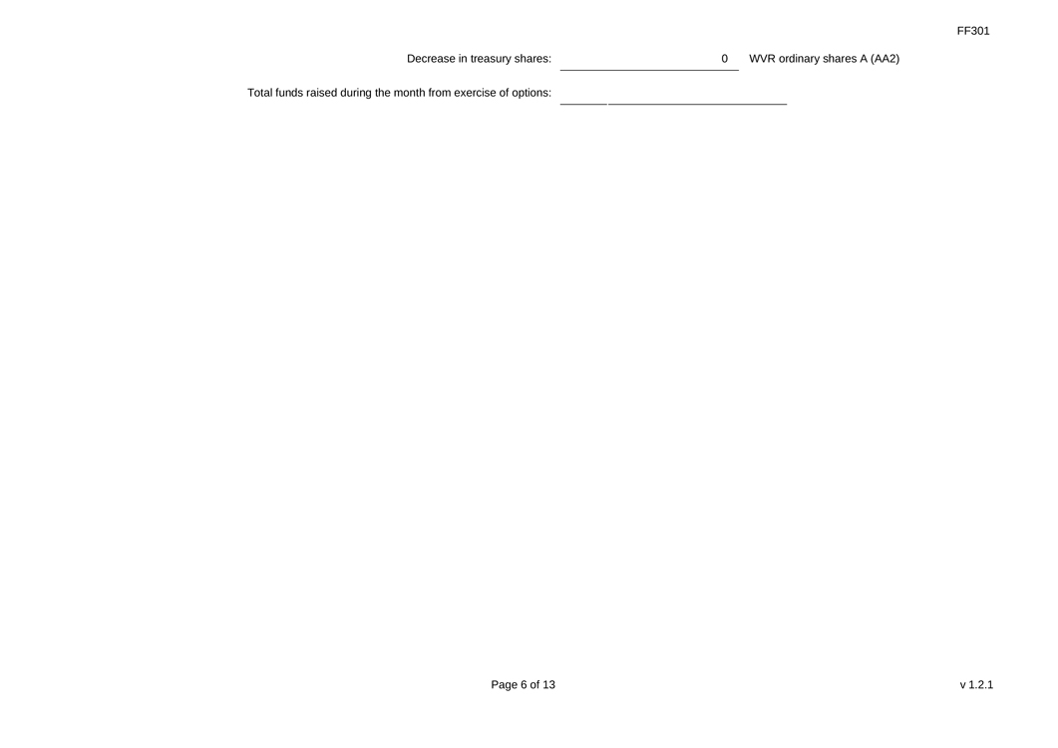
FF301 Decrease in treasury shares: Total funds raised during the month from exercise of options: 0 WVR ordinary shares A (AA2) Page 6 of 13 v1.2.1


FF301 (B). Warrants to Issue Shares of the Issuer Not applicable Page 7 of 13 v1.2.1

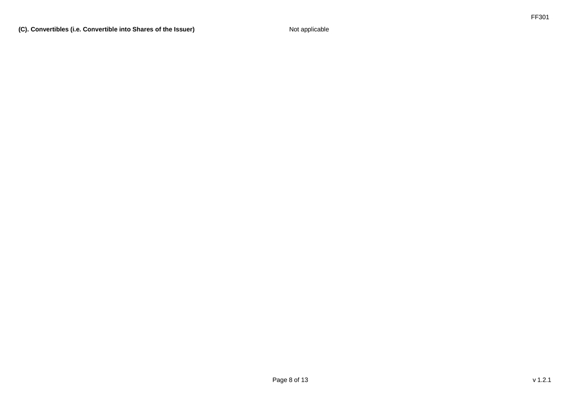
FF301 (C). Convertibles (i.e. Convertible into Shares of the Issuer) Not applicable Page 8 of 13 v1.2.1

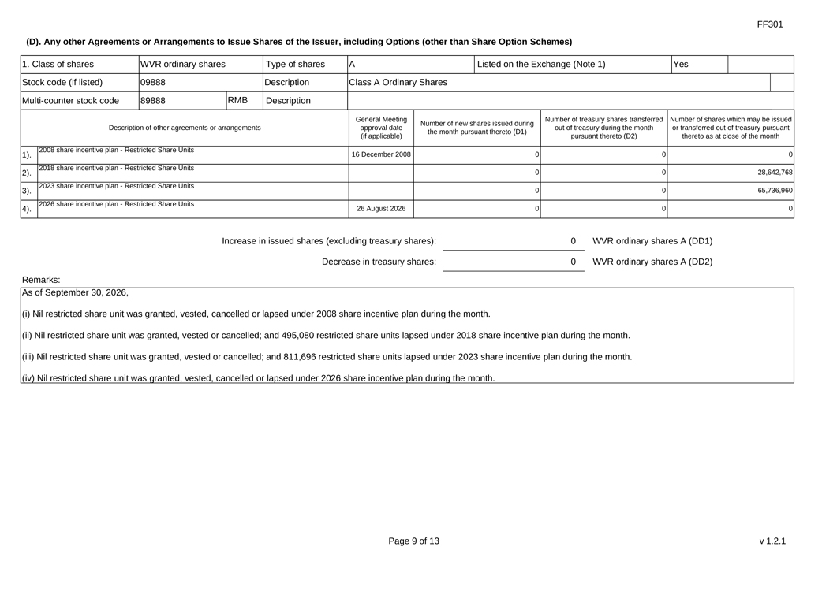
FF301 1. Class of shares Stock code (if listed) Multi-counter stock code A Class A Ordinary Shares RMB Type of shares Description Description Yes Number of new shares issued during the month pursuant thereto (D1) Number of treasury shares transferred | Number of shares which may be issued out of treasury during the month pursuant thereto (D2) or transferred out of treasury pursuant thereto as at close of the month 1) General Meeting approval date (if applicable) 16 December 2008 2). 3) 4). WVR ordinary shares 09888 89888 Description of other agreements or arrangements 2008 share incentive plan—Restricted Share Units 2018 share incentive plan—Restricted Share Units 2023 share incentive plan- Restricted Share Units 2026 share incentive plan—Restricted Share Units (D). Any other Agreements or Arrangements to Issue Shares of the Issuer, including Options (other than Share Option Schemes) Listed on the Exchange (Note 1) 28,642,768 65,736,960 26 August 2026 O O O Increase in issued shares (excluding treasury shares): Decrease in treasury shares: 00 WVR ordinary shares A (DD1) WVR ordinary shares A (DD2) Remarks: As of September 30, 2026, (0) Nil restricted share unit was granted, vested, cancelled or lapsed under 2008 share incentive plan during the month. (i) Nil restricted share unit was granted, vested or cancelled; and 495,080 restricted share units lapsed under 2018 share incentive plan during the month. (ii) Nil restricted share unit was granted, vested or cancelled; and 811,696 restricted share units lapsed under 2023 share incentive plan during the month. (iv) Nil restricted share unit was granted, vested, cancelled or lapsed under 2026 share incentive plan during the month. Page 9 of 13 v 1.2.1

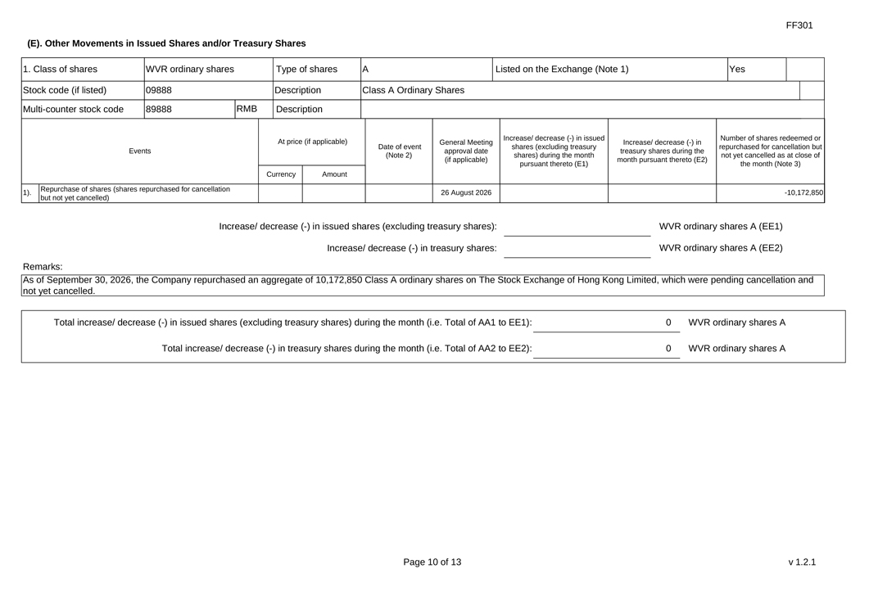
FF301 (E). Other Movements in Issued Shares andlor Treasury Shares 1. Class of shares Stock code (if listed) Multi-counter stock code WVR ordinary shares 09888 89888 A Yes Class A Ordinary Shares RMB Type of shares Description Description Listed on the Exchange (Note 1) Events At price (if applicable) Date of event (Note 2) General Meeting approval date (if applicable) Increase/ decrease (-) in issued shares (excluding treasury shares) during the month pursuant thereto (E1) Increase/ decrease (-) in treasury shares during the month pursuant thereto (E2) Number of shares redeemed or repurchased for cancellation but not yet cancelled as at close of the month (Note 3) Currency Amount 1). Repurchase of shares (shares repurchased for cancellation out not yet cancelled) 26 August 2026 -10,172,850 Remarks: Increase/ decrease (-) in issued shares (excluding treasury shares): Increase/ decrease (-) in treasury shares: As of September 30, 2026, the Company repurchased an aggregate of 10,172,850 Class A ordinary shares on The Stock Exchange of Hong Kong Limited, which were pending cancellation and not yet cancelled. Total increase/ decrease (-) in issued shares (excluding treasury shares) during the month (i.e. Total of AA1 to EE1): Total increase/ decrease (-) in treasury shares during the month (i.e. Total of AA2 to EE2): WVR ordinary shares A (EE1) WVR ordinary shares A (EE2) o O WVR ordinary shares A WVR ordinary shares A Page 10 of 13 v 1.2.1

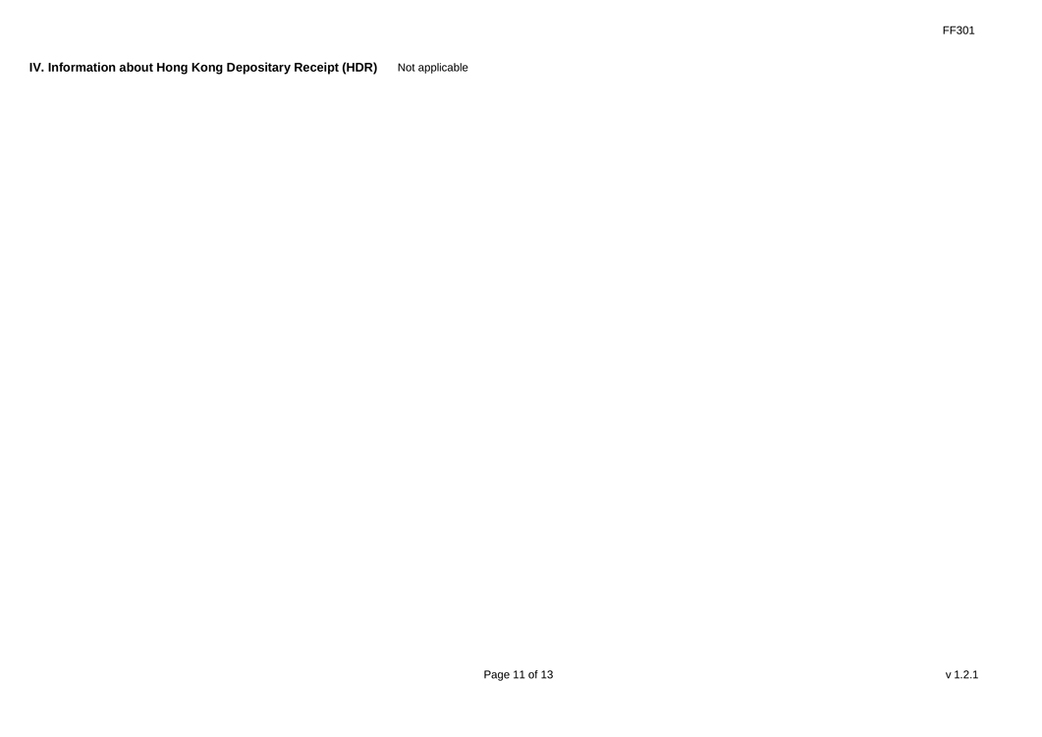
FF301 IV. Information about Hong Kong Depositary Receipt (HDR) Not applicable Page 11 of 13 v1.2.1

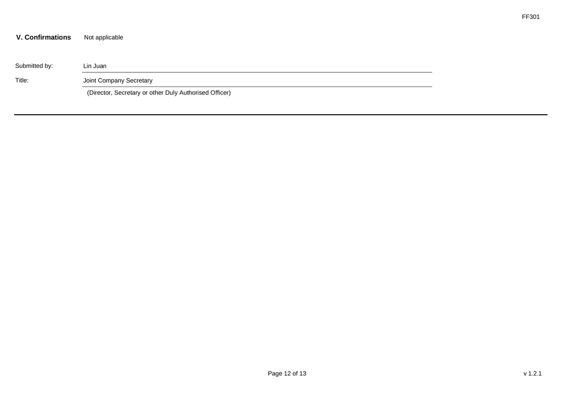
FF301 V. Confirmations Not applicable Submitted by: Title: Lin Juan Joint Company Secretary (Director, Secretary or other Duly Authorised Officer) Page 12 of 13 v1.2.1

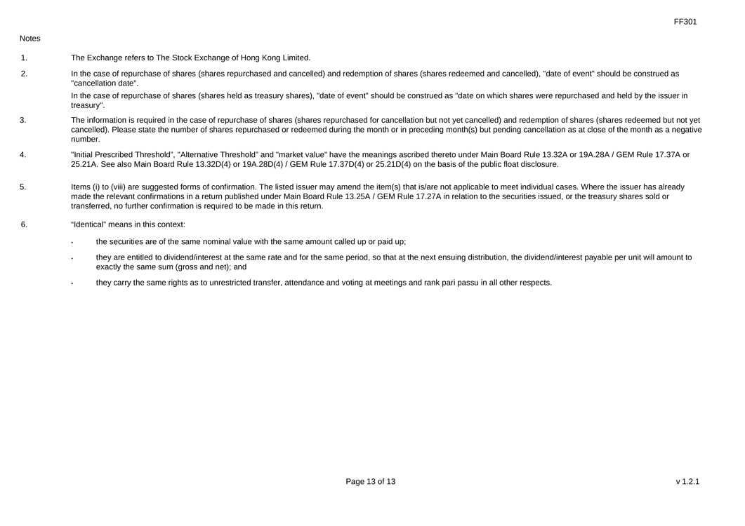
FF301 Notes 1. 2. 3 4 5. 6 The Exchange refers to The Stock Exchange of Hong Kong Limited. In the case of repurchase of shares (shares repurchased and cancelled) and redemption of shares (shares redeemed and cancelled), “date of event” should be construed as “cancellation date”. In the case of repurchase of shares (shares held as treasury shares), “date of event” should be construed as “date on which shares were repurchased and held by the issuer in treasury”. The information is required in the case of repurchase of shares (shares repurchased for cancellation but not yet cancelled) and redemption of shares (shares redeemed but not yet cancelled). Please state the number of shares repurchased or redeemed during the month or in preceding month(s) but pending cancellation as at close of the month as a negative number. “Initial Prescribed Threshold”, “Alternative Threshold” and “market value” have the meanings ascribed thereto under Main Board Rule 13.32A or 19A.28A / GEM Rule 17.37A or 25.21A. See also Main Board Rule 13.32D(4) or 19A.28D(4) / GEM Rule 17.37D(4) or 25.21D(4) on the basis of the public float disclosure. Items (i) to (viii) are suggested forms of confirmation. The listed issuer may amend the item(s) that is/are not applicable to meet individual cases. Where the issuer has already made the relevant confirmations in a return published under Main Board Rule 13.25A / GEM Rule 17.27A in relation to the securities issued, or the treasury shares sold or transferred, no further confirmation is required to be made in this return. “Identical” means in this context: the securities are of the same nominal value with the same amount called up or paid up; they are entitled to dividend/interest at the same rate and for the same period, so that at the next ensuing distribution, the dividend/interest payable per unit will amount to exactly the same sum (gross and net); and they carry the same rights as to unrestricted transfer, attendance and voting at meetings and rank pari passu in all other respects. Page 13 of 13 v1.2.1

