UNITED STATES
SECURITIES AND EXCHANGE COMMISSION
WASHINGTON, D.C. 20549

FORM 6-K

REPORT OF FOREIGN PRIVATE ISSUER
PURSUANT TO RULE 13a-16 OR 15d-16
UNDER THE SECURITIES EXCHANGE ACT OF 1934
For the month of October 2026
Commission File Number: 000-51469

BAIDU, INC.

Baidu Campus
No. 10 Shangdi 10th Street
Haidian District, Beijing 100085
The People’s Republic of China
(Address of principal executive offices)

Indicate by check mark whether the registrant files or will file annual reports under cover of Form 20-F or Form 40-F.
Form 20-F ☒ Form 40-F ☐

EXHIBIT INDEX

Exhibit No. |  | Description
99.1 |  | Next Day Disclosure Return, dated September 30, 2026

SIGNATURES
Pursuant to the requirements of the Securities Exchange Act of 1934, the registrant has duly caused this report to be signed on its behalf by the undersigned, thereunto duly authorized.

BAIDU, INC.
By: |  | /s/ Haijian He
Name: |  | Haijian He
Title: |  | Chief Financial Officer
Date: October 1, 2026
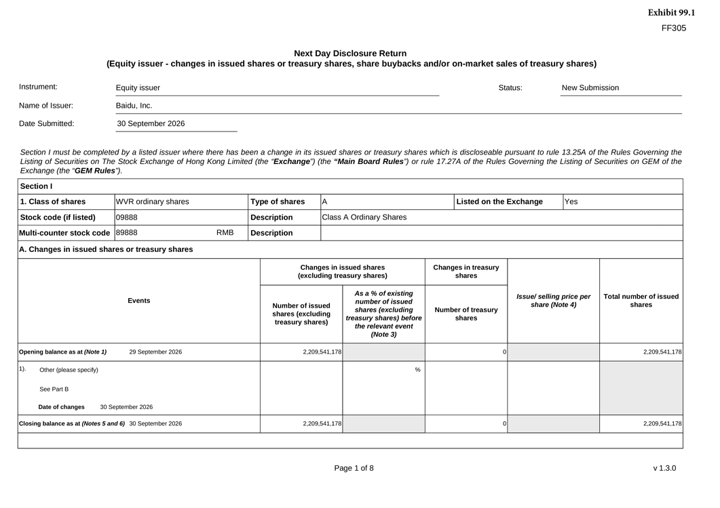
FF305 Next Day Disclosure Return (Equity issuer—changes in issued shares or treasury shares, share buybacks and/or on-market sales of treasury shares) Instrument: Equity issuer Status:New Submission Name of Issuer:Baidu, Inc. Date Submitted:30 September 2026 Section I must be completed by a listed issuer where there has been a change in its issued shares or treasury shares which is discloseable pursuant to rule 13.25A of the Rules Governing the Listing of Securities on The Stock Exchange of Hong Kong Limited (the “Exchange”) (the “Main Board Rules”) or rule 17.27A of the Rules Governing the Listing of Securities on GEM of the Exchange (the “GEM Rules”). Section I 1. Class of shares WVR ordinary sharesType of sharesAListed on the ExchangeYes Stock code (if listed)09888DescriptionClass A Ordinary Shares Multi-counter stock code89888RMBDescription A. Changes in issued shares or treasury shares EventsChanges in issued shares (excluding treasury shares)Changes in treasury shares Issue/ selling price per share (Note 4) Total number of issued shares Number of issued shares (excluding treasury shares)As a % of existing number of issued shares (excluding treasury shares) before the relevant event (Note 3) Number of treasury shares Opening balance as at (Note 1)29 September 20262,209,541,17802,209,541,178 1).Other (please specify) See Part B Date of changes30 September 2026% Closing balance as at (Notes 5 and 6) 30 September 20262,209,541,17802,209,541,178

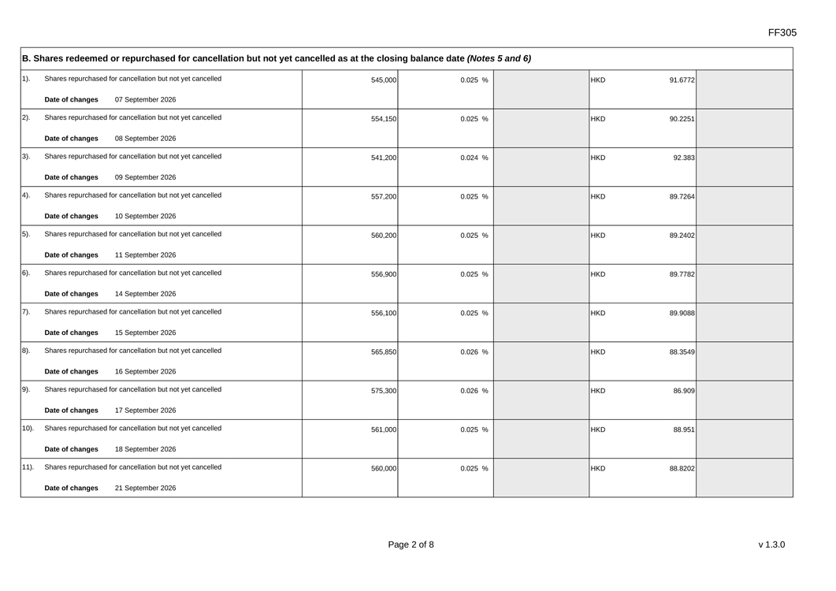
FF305 B. Shares redeemed or repurchased for cancellation but not yet cancelled as at the closing balance date (Notes 5 and 6) 1). Shares repurchased for cancellation but not yet cancelled Date of changes 07 September 2026 545,000 0.025 % HKD 91.6772 2). Shares repurchased for cancellation but not yet cancelled Date of changes 08 September 2026 554,150 0.025 % HKD 90.2251 3). Shares repurchased for cancellation but not yet cancelled Date of changes09 September 2026 541,200 0.024 % HKD 92.383 4). Shares repurchased for cancellation but not yet cancelled Date of changes10 September 2026 557,200 0.025 % HKD 89.7264 5). Shares repurchased for cancellation but not yet cancelled Date of changes11 September 2026 560,200 0.025 % HKD 89.2402 6). Shares repurchased for cancellation but not yet cancelled Date of changes14 September 2026 556,900 0.025 % HKD 89.7782 7). Shares repurchased for cancellation but not yet cancelled Date of changes15 September 2026 556,100 0.025 % HKD 89.9088 8). Shares repurchased for cancellation but not yet cancelled Date of changes16 September 2026 565,850 0.026 % HKD 88.3549 9). Shares repurchased for cancellation but not yet cancelled Date of changes17 September 2026 575,300 0.026 % HKD 86.909 10). Shares repurchased for cancellation but not yet cancelled Date of changes18 September 2026 561,000 0.025 % HKD 88.951 11). Shares repurchased for cancellation but not yet cancelled Date of changes21 September 2026 560,000 0.025 % HKD 88.8202

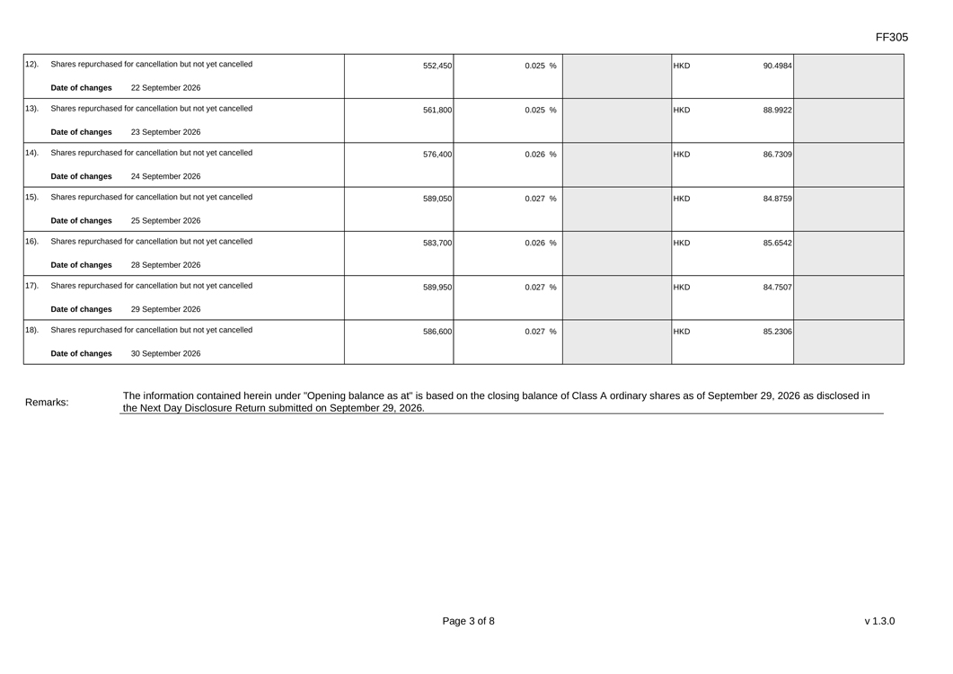
12). Shares repurchased for cancellation but not yet cancelled Date of changes 22 September 2026552,4500.025 %HKD90.4984 13).Shares repurchased for cancellation but not yet cancelled Date of changes23 September 2026561,8000.025 %HKD88.9922 14).Shares repurchased for cancellation but not yet cancelled Date of changes24 September 2026576,4000.026 %HKD86.7309 15).Shares repurchased for cancellation but not yet cancelled Date of changes25 September 2026589,0500.027 %HKD84.8759 16).Shares repurchased for cancellation but not yet cancelled Date of changes28 September 2026583,7000.026 %HKD85.6542 17).Shares repurchased for cancellation but not yet cancelled Date of changes29 September 2026589,9500.027 %HKD84.7507 18).Shares repurchased for cancellation but not yet cancelled Date of changes30 September 2026586,6000.027 %HKD85.2306 Remarks:The information contained herein under “Opening balance as at” is based on the closing balance of Class A ordinary shares as of September 29, 2026 as disclosed in the Next Day Disclosure Return submitted on September 29, 2026.

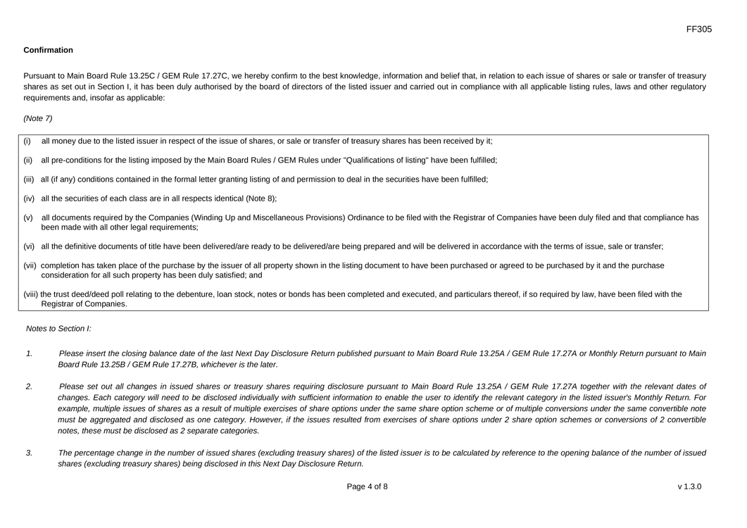
Confirmation Pursuant to Main Board Rule 13.25C / GEM Rule 17.27C, we hereby confirm to the best knowledge, information and belief that, in relation to each issue of shares or sale or transfer of treasury shares as set out in Section I, it has been duly authorised by the board of directors of the listed issuer and carried out in compliance with all applicable listing rules, laws and other regulatory requirements and, insofar as applicable: (Note 7) (i) all money due to the listed issuer in respect of the issue of shares, or sale or transfer of treasury shares has been received by it; (ii) all pre-conditions for the listing imposed by the Main Board Rules / GEM Rules under “Qualifications of listing” have been fulfilled; (iii)all (if any) conditions contained in the formal letter granting listing of and permission to deal in the securities have been fulfilled; (iv)all the securities of each class are in all respects identical (Note 8); (v)all documents required by the Companies (Winding Up and Miscellaneous Provisions) Ordinance to be filed with the Registrar of Companies have been duly filed and that compliance has been made with all other legal requirements; (vi)all the definitive documents of title have been delivered/are ready to be delivered/are being prepared and will be delivered in accordance with the terms of issue, sale or transfer; (vii)completion has taken place of the purchase by the issuer of all property shown in the listing document to have been purchased or agreed to be purchased by it and the purchase consideration for all such property has been duly satisfied; and (viii)the trust deed/deed poll relating to the debenture, loan stock, notes or bonds has been completed and executed, and particulars thereof, if so required by law, have been filed with the Registrar of Companies. Notes to Section I: 1.Please insert the closing balance date of the last Next Day Disclosure Return published pursuant to Main Board Rule 13.25A / GEM Rule 17.27A or Monthly Return pursuant to Main Board Rule 13.25B / GEM Rule 17.27B, whichever is the later. 2.Please set out all changes in issued shares or treasury shares requiring disclosure pursuant to Main Board Rule 13.25A / GEM Rule 17.27A together with the relevant dates of changes. Each category will need to be disclosed individually with sufficient information to enable the user to identify the relevant category in the listed issuer’s Monthly Return. For example, multiple issues of shares as a result of multiple exercises of share options under the same share option scheme or of multiple conversions under the same convertible note must be aggregated and disclosed as one category. However, if the issues resulted from exercises of share options under 2 share option schemes or conversions of 2 convertible notes, these must be disclosed as 2 separate categories. 3.The percentage change in the number of issued shares (excluding treasury shares) of the listed issuer is to be calculated by reference to the opening balance of the number of issued shares (excluding treasury shares) being disclosed in this Next Day Disclosure Return.

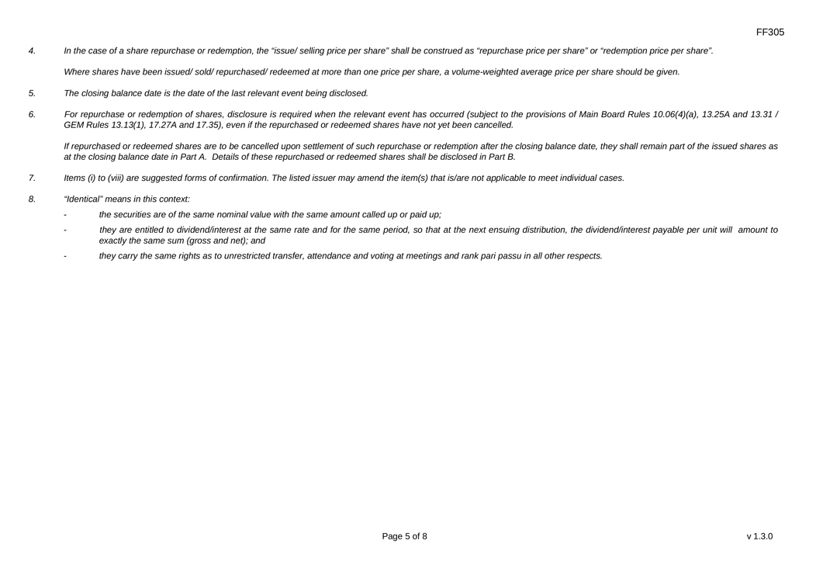
4. In the case of a share repurchase or redemption, the “issue/ selling price per share” shall be construed as “repurchase price per share” or “redemption price per share”. Where shares have been issued/ sold/ repurchased/ redeemed at more than one price per share, a volume-weighted average price per share should be given. 5. The closing balance date is the date of the last relevant event being disclosed. 6.For repurchase or redemption of shares, disclosure is required when the relevant event has occurred (subject to the provisions of Main Board Rules 10.06(4)(a), 13.25A and 13.31 / GEM Rules 13.13(1), 17.27A and 17.35), even if the repurchased or redeemed shares have not yet been cancelled. If repurchased or redeemed shares are to be cancelled upon settlement of such repurchase or redemption after the closing balance date, they shall remain part of the issued shares as at the closing balance date in Part A. Details of these repurchased or redeemed shares shall be disclosed in Part B. 7.Items (i) to (viii) are suggested forms of confirmation. The listed issuer may amend the item(s) that is/are not applicable to meet individual cases. 8. “Identical” means in this context: -the securities are of the same nominal value with the same amount called up or paid up; -they are entitled to dividend/interest at the same rate and for the same period, so that at the next ensuing distribution, the dividend/interest payable per unit will amount to exactly the same sum (gross and net); and -they carry the same rights as to unrestricted transfer, attendance and voting at meetings and rank pari passu in all other respects.

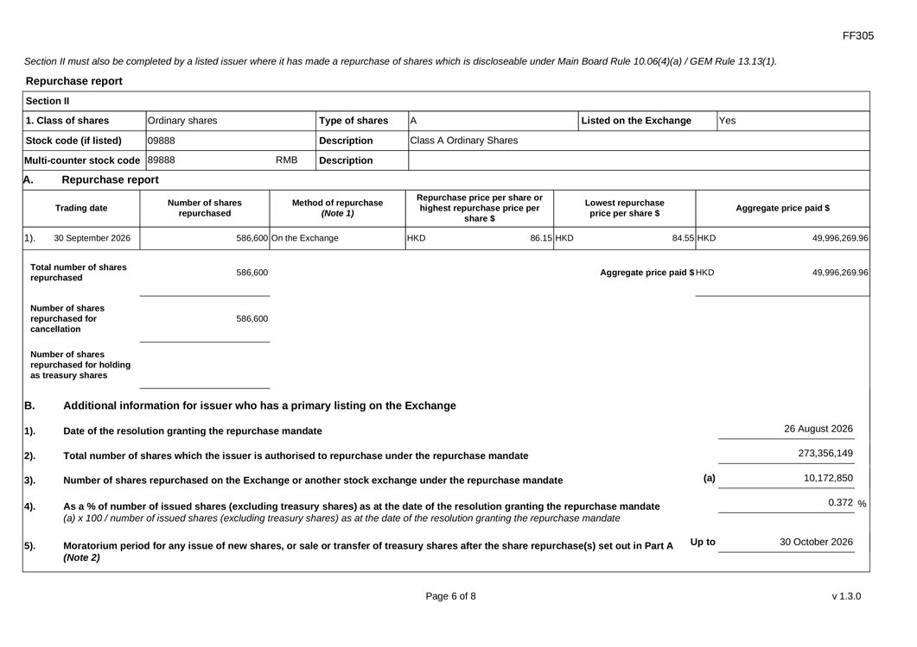
Section II must also be completed by a listed issuer where it has made a repurchase of shares which is discloseable under Main Board Rule 10.06(4)(a) / GEM Rule 13.13(1). Repurchase report Section II 1. Class of shares Ordinary sharesType of sharesAListed on the ExchangeYes Stock code (if listed)09888DescriptionClass A Ordinary Shares Multi-counter stock code 89888RMBDescription A.Repurchase report Number of sharesMethod of repurchaseRepurchase price per share or Lowest repurchase Trading daterepurchased(Note 1)highest repurchase price perprice per share $Aggregate price paid $ share $ 1).30 September 2026586,600 On the ExchangeHKD86.15 HKD84.55 HKD49,996,269.96 Total number of shares586,600Aggregate price paid $ HKD49,996,269.96 repurchased Number of shares repurchased for586,600 cancellation Number of shares repurchased for holding as treasury shares B. 1). Additional information for issuer who has a primary listing on the Exchange Date of the resolution granting the repurchase mandate 26 August 2026 2). Total number of shares which the issuer is authorised to repurchase under the repurchase mandate 273,356,149 3). Number of shares repurchased on the Exchange or another stock exchange under the repurchase mandate (a) 10,172,850 0.372 % Up to 30 October 2026

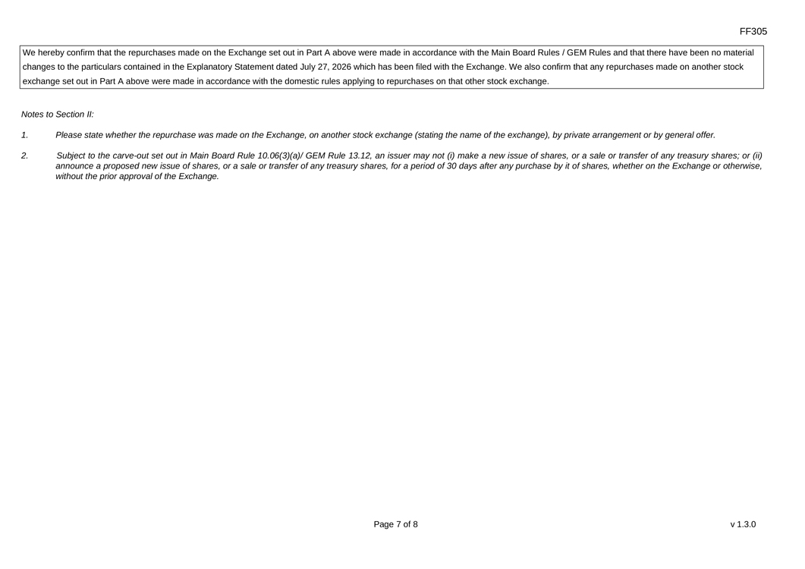
Notes to Section II: 1. Please state whether the repurchase was made on the Exchange, on another stock exchange (stating the name of the exchange), by private arrangement or by general offer. 2. Subject to the carve-out set out in Main Board Rule 10.06(3)(a)/ GEM Rule 13.12, an issuer may not (i) make a new issue of shares, or a sale or transfer of any treasury shares; or (ii) announce a proposed new issue of shares, or a sale or transfer of any treasury shares, for a period of 30 days after any purchase by it of shares, whether on the Exchange or otherwise, without the prior approval of the Exchange.

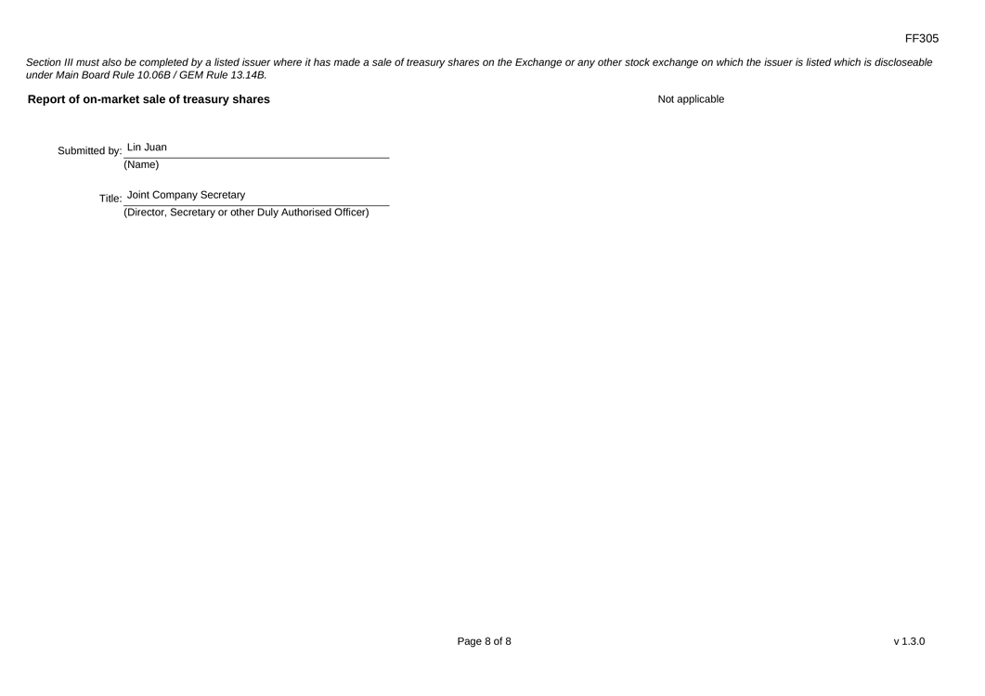
Section III must also be completed by a listed issuer where it has made a sale of treasury shares on the Exchange or any other stock exchange on which the issuer is listed which is discloseable under Main Board Rule 10.06B / GEM Rule 13.14B. Report of on-market sale of treasury shares Not applicable Submitted by: Lin Juan (Name) Title: Joint Company Secretary (Director, Secretary or other Duly Authorised Officer)

